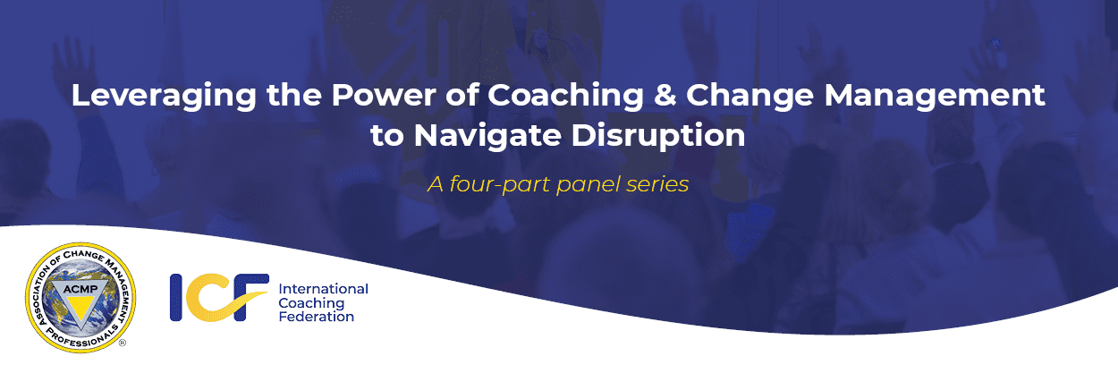

|  |  |
| --- | --- |
| |  | | --- | | Dear <Client>,  On behalf of ICF Toronto, we would like to invite you to an upcoming webinar series hosted jointly by The [International Coaching Federation](https://coachingfederation.org/) (ICF) and the [Association of Change Management Professionals (ACMP)](https://gm204.infusion-links.com/api/v1/click/6536782298087424/5134273354924032). ICF Global and ACMP Global have been proactively exploring the numerous synergies between change management and coaching, particularly the power of coaching in organizational change initiatives. The goals of this collaboration are to:   1. Explore how these two professions complement each other 2. Support the continued development of shared competencies 3. Build organizational resilience 4. Increase value to members in both   We are excited to announce the result of this collaboration: ***Leveraging the Power of Coaching & Change Management to Navigate Disruption*, a four-part webinar series beginning March 2021.**  This **FREE panel series** will be led by **experienced coaching and change management practitioners, as well as industry leaders** who will share how they leverage both disciplines with regards to four unique topics. | |
| |  |  | | --- | --- | | |  | | --- | | [**Learn More**](https://gm204.infusion-links.com/api/v1/click/4637509222531072/5134273354924032) | | |

|  |  |
| --- | --- |
| |  | | --- | | **Social Justice | March 17, 2021, at 12 noon (New York)**  Expert practitioners in coaching and change management will share how they are addressing social justice issues in working with their clients or organizations. Guest panellists have been announced and profiles are also included.  [**Register for free with ACMP here.**](https://gm204.infusion-links.com/api/v1/click/4777078479781888/5134273354924032)  **Leadership from the Front Lines | April 14, 2021, at 12 noon (New York)**  Leaders from different industries will share what they learned about leadership while managing seismic external forces and changes related to health, safety, working from home, stress management, social justice, politics and the economy, and equality in their organizations.  [**Register for free with ICF here.**](https://gm204.infusion-links.com/api/v1/click/5751813254545408/5134273354924032)  **Re-Opening after the Pandemic | May 19, 2021, at 12 noon (New York)**  Expert practitioners in change management and coaching will share how they are supporting organizations to pivot to virtual, re-open offices, or embrace a new hybrid approach and how they support employees and leaders to address physical and psychological safety and adapt to the new way(s) of working.  [**Register for free with ACMP here.**](https://gm204.infusion-links.com/api/v1/click/5781372561653760/5134273354924032)  **Coaching Change Leaders | June 16, 2021, at 12 noon (New York)**  Experts in both coaching and change management will share how they leverage both disciplines to support leaders who are driving transformational change, and the value of being certified in both disciplines. Furthermore, they will share lessons learned on how best to blend coaching and change management to support organizational transformation.  [**Register for free with ICF here.**](https://gm204.infusion-links.com/api/v1/click/5889645952499712/5134273354924032)  We hope you find this series thought provoking and enlightening as you explore these topics within your organizations. | |
| |  | | --- | |  | |

|  |  |
| --- | --- |
| |  | | --- | | [CF and ACMP logos](https://gm204.infusion-links.com/api/v1/click/5922354208833536/5134273354924032) | |